Hello!

The following is information for each NACRAO College Fair scheduled the week of August 31st through September 4th. These emails will be going out to all NACRAO Reps, if your college did not register for these fairs, please ignore as it is to assure everyone receives the information needed for travel! Please forward this information to any representatives who will be attending these events.
If you have any questions about an event, or will no longer be able to attend an event, please contact the host site directly (contact information is below). Also, check out our Weekly Socials below for a chance to get together with the other reps on the road!

*As a reminder we are using StriveScan as our college fair scanning app! Be sure to purchase a per fair you wish to attend (only one credit needed per school). If you're not familiar with StriveScan, you can watch a quick, 2-minute video on how it works.

Monday, August 31st
Mullen Area College Fair
10:00 to 11:00am (MST)
Location: Lariat Center
Address: The Lariat Gym 205 S Washington Ave, Mullen, NE 69152 (GPS not the best directions… It’s on the corner of Highway 2 and Highway 97, south of the highway across from the Kwik Stop).

Host Site Contact: Kara Connealy, Cell phone: 308-650-0747. Email: kara.connealy@mullenpublicschools.org. School phone: 308-546-2223. Please use my cell phone the day of the fair as the fair is not located at the high school. Representatives may park on any side of the Lariat. Door entrances are on the south and east sides of the building. Reps may begin setting up any time after 9:00 am.

High schools Invited: Mullen, Thedford, Dunning, McPherson County, Hyannis, and Valentine. Approximately 150
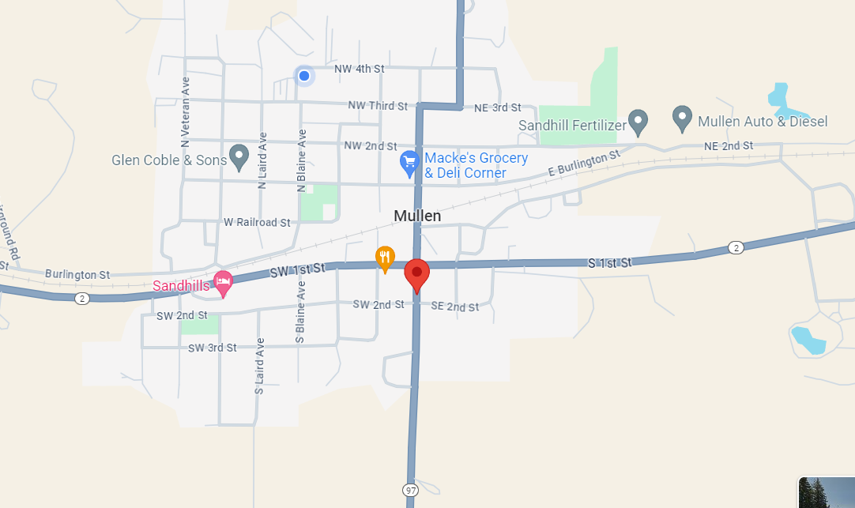

Alliance Area College Fair
2:00PM- 3:00PM (MST)
Location: Alliance High School
Address: 1450 Box Butte Avenue in Alliance, NE
Host Site Contact Information: Nate Lanik; nate.lanik@alliancebulldogs.org
Details: Representatives may park in the north lot or on the street of Alliance High School and can enter through the doors on the North side of the building. Reps may begin setting up any time after 1:00 pm.

High Schools Invited: Alliance High School, Hemingford High School, and Hyannis High School. Approximately 250 students are expected to attend.

Tuesday, September 1st
Chadron Area College Fair
9:00AM- 10:30AM (MST)
Location: Chadron State College – Chicoine Center, Upper Concourse
Address: 375 E 12th St, Chadron, NE 693337
Host Site Contact: Gabi Perez- Patterson, 541-543-6911
Details: Representatives may park in the lot west of Chicoine Center and can enter through the doors on the west side of the building. There will be signs up to direct you. Reps may begin setting up any time after 8:00 am. Coffee, Water and breakfast items will be provided to reps.
An interactive map can be found here: https://map.concept3d.com/?id=798#!ct/94704,94706,94707?s/?sbc/
High schools Invited: Chadron High School, Gordon-Rushville High School, Hay Springs High School, Sioux County High School, and Crawford High School.
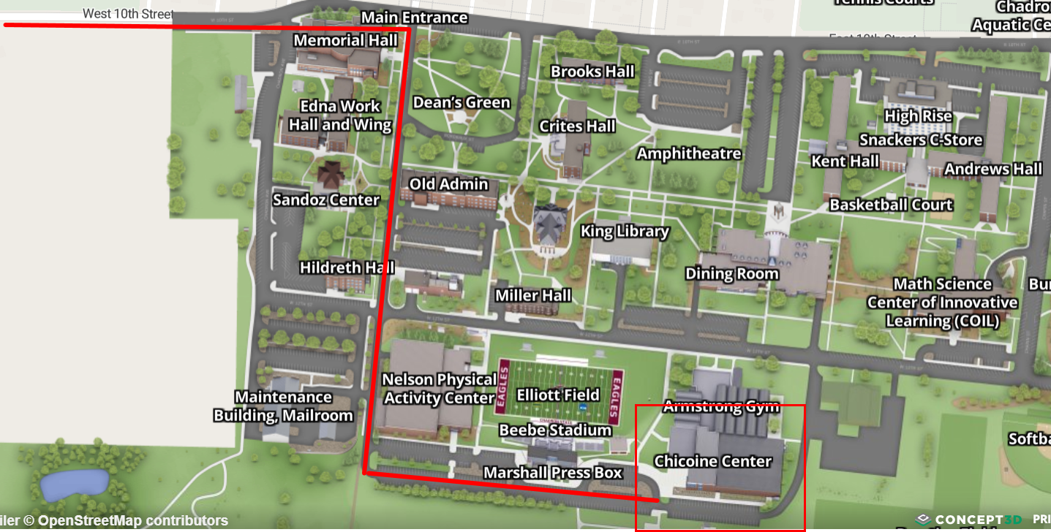

Scottsbluff Area College Fair
1:30PM- 3:00PM (MST)
Location: Western Nebraska Community College- Cougar Palace Gym
Address: 1601 E. 27th Street Scottsbluff, NE 69361
Contact: Jolene Martin jolene@wncc.edu, Connagher Stumpff connagher@wncc.edu 308-635-6010
Details: The college fair will be held in Cougar palace. Feel free to arrive and set-up as early as 11:00 AM. If you are headed this way after the Chadron fair, we will see you shortly after noon.

Parking and entering the building (see map)
Front parking lots - two smaller parking lots by main entrance. You are welcome to park here and enter at the main entrance. From here there is a direct entrance to Cougar Palace with no stairs.
West side lot - Door 6 or Learning Commons entrance. Both entrances have stairs that lead down to Cougar palace and there is also elevator access.

Tables will be assigned. Feel free to keep your sign on your table, or remove it; your preference. They sit high and allow students to see your college name in a crowded setting.

We will have light snacks and drinks for you. Buddy's Books and Bistro is also up above Cougar Palace where you can purchase snacks, pizzas, burritos, cold drinks, candy and custom coffee and Lotus drinks.

High Schools invited: Banner County, Bayard, Bridgeport, Choices, Gering, Kimball, Minatare, Mitchell, Morrill, Reconnect, Scottsbluff, and Vaults

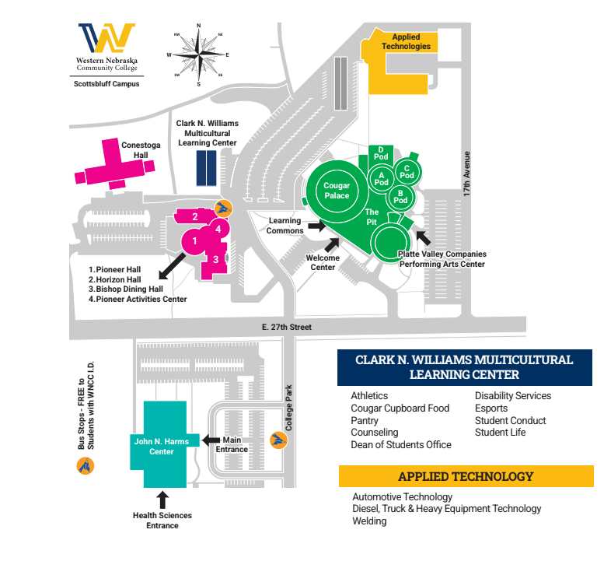

Wednesday, September 2nd
Sidney Area College Fair
9:00AM- 10:00AM (MST)
Location: Sidney High School
Address: 1100 19th Avenue, Sidney NE 69162
Host Site Contact: Kelle Dillehay; 308-254-5893 ext: 305; kelle.dillehay@raidermail.org
Details: Representatives may park along 19th Avenue. Enter through the main doors on the east. You may also park in the west parking lot. Enter doors on the west side. Reps may begin setting up any time after 8:30 am.

High Schools Invited: Creek Valley High School, Kimball High School, Leyton High School, Potter Dix High School.

Ogallala Area College Fair
1:30 to 2:30PM (MST)
Location: Ogallala Senior High School
Address: 602 East 6th Street, Ogallala, NE 69153
Contact Information: Jennifer Bekke, 308-284-4029, jenniferbekke@opsd.org
Entrance Instructions: Parking will be in the big parking lot on the west side of the building or on the street in front of the school. Enter in through the office doors on the south side of the building. Fair will be held in the gym and a host will be there to greet and show you where to go. Set up time: 12:15 – 1:00

High Schools Invited: Chase County Schools, Garden County High School, Paxton Consolidated Schools, Perkins County Schools, South Platte Public Schools.

Weekly Social!
Date: Wednesday, September 2nd
Town: North Platte
Location: Pals Brewing Company
Time: 6:00pm
*We are going to set up weekly socials for everyone to meet up during the week, grab a bite, unwind from travel and socialize and watch “the game”. This will not be a NACRAO sponsored event so come and go as you please. We look forward to seeing you all there!

Thursday, September 3rd
North Platte Area College Fair
8:30 to 10:00AM (CST)
Location: North Platte High School
Address: 1220 W 2nd Street, North Platte, NE 69101
Host Site Contact: Amie Albrecht, aalbrecht@nppsd.org, Sky Schute, sschute@nppsd.org
719.760.9615: Amie’s cell
Representatives may park in the lot in front of the school and enter through the main doors
of the building. Reps may begin setting up any time after 7:30 am. Reps must bring their driver’s license to be admitted to the building. You will have to scan to enter the building. Please plan accordingly.

High Schools Invited: Brady, Hershey, Maxwell, Maywood, Medicine Valley North Platte, St. Patrick’s, Stapleton, Sutherland, Wallace.

McCook Area College Fair
1:30 to 3:00PM (CST)
Location: McCook High School
School Address: 600 W 7th St. McCook 69001
Host Site Contact Information: Jordan Lewis, jlewis@mccookbison.org
Details: Park in any street parking around the building. Enter through Door 2 by the marquee sign. Turn left once in the building to head to the gym. Fair will be held in main gym.

High Schools Invited: Dundy County, Hayes Center, Hitchcock County, Maywood, McCook, Medicine Valley, Southwest (Bartley), Wauneta-Palisade.

Friday, September 4th
Lexington Area College Fair
9:00AM- 10:30AM (CST)
Location: Lexington High School
Address: 1400 Minuteman Dr, Lexington, NE 68850
Host Site Contact: Contact: Joel Lemus 308-324-1272 joel.lemus@lexschools.org, Cyndi Hoyt 308-324-1269 cyndi.hoyt@lexschools.org, Reyna Clouse 308-324-1261 reyna.clouse@lexschools.org

Details: Parking will be available on the south side of the school just off of 13th Street. The area will be blocked off with cones and you will be waved in by our students. You will be directed to the main entrance where you will check in at the main office and then proceed to the West Gym. See map below.

High Schools Invited: Cozad, Elwood, Eustis-Farnam, Gothenburg, Lexington, Overton, Sumner/Eddyville/Miller

