Hello!

The following is information for each NACRAO College Fair scheduled the week of September 9th and September 10th. These emails will be going out to all NACRAO Reps, if your college did not register for these fairs, please ignore as it is to assure everyone receives the information needed for travel! Please forward this information to any representatives who will be attending these events.

If you have any questions about an event, or will no longer be able to attend an event, please contact the host site directly (contact information is below).

*As a reminder we are using StriveScan as our college fair scanning app! Be sure to purchase a per fair you wish to attend (only one credit needed per school). If you're not familiar with StriveScan, you can watch a quick, 2-minute video on how it works.
Wednesday, September 9th
Fremont Area College Fair
9:00 to 10:30am
Location: Fremont High School
Address: 1750 N Lincoln Ave, Fremont, NE 68025
Host Site Contact: Rachel Fredrickson Rachel.fredrickson@fpsmail.org
Host Site Details: When arriving, Colleges can park in the north parking lot and enter through the Bahe Gym doors. There will be someone waiting at this entrance to help with directions. There will also be a Business Fair going on this same day. They will also park in the North Lot but enter the CTE Entrance. See map below.
High schools Invited: Archbishop Bergan Catholic School, Arlington Public Schools, Bennington High School, Bishop Neumann High School, Blair High School, Cedar Bluffs High School, DC West High School, Guardian Angels Central Catholic High School, Howells-Dodge Consolidated School, Logan View Public Schools, Lyons-Decator Northeast School, Mead Public Schools, North Bend Central High School, Oakland-Craig Public Schools, Scribner-Snyder Jr-Sr High School, Tekamah-Herman Schools, Wahoo Public Schools.
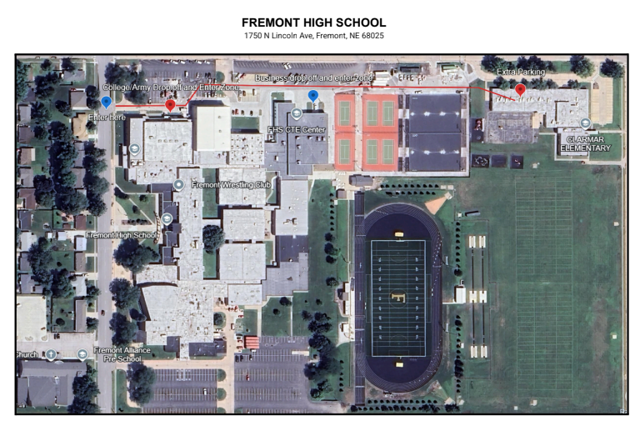

Omaha Westview College Fair
12:00 to 1:30pm
Location: Westview High School
Address: 15800 Summit Plz, Bennington, NE 68007
Host Site Contact: Alyssa Krogstrand - alyssa.krogstrand@ops.org; 531-299-3937

Host Site Details: We will have the gym set up at 11:30 for reps. Parking will be in the south senior lot. Please do not park in a painted spot. Push the call button to the left for entrance. Please check in at the front office.

High schools Invited: Westview High School

Thursday, September 10th
Bellevue Area College Fair
9:00 to 11:00am
Location: Bellevue Lied Center
Address: 2700 Arboretum Dr., Bellevue, NE. 68005
Host Site Contact: Randy Schultz (402) 213-8824, randall.schultz@bpsne.net or
Kathie Britten (402) 350-7216, kathie.britten@bpsne.net
Host Site Details: Parking (see red rectangle on map)–Bellevue Public School Buses will be dropping off students at the main doors and picking them
up using the rear exit doors. Enter through the main doors to the Lied Center. From there, someone will show you to your reserved table. Can begin setting up at 8:30am.

High schools Invited: Bellevue East and Bellevue West

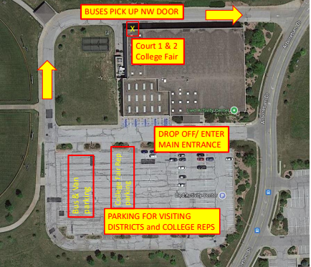

Conestoga Area College Fair
1:00 to 2:00pm
Location: Conestoga High School
Address: 8404 42nd St, Murray, NE 68409
Host Site Contact: Jeff Brokaw, jbrokaw@conestogacougars.org

Host Site Details: See map below. The school is under construction therefore please park in the “loop” and drive up and park in the grass as illustrated in the map below. Enter in main entrance.

High schools Invited: Ashland Greenwood, Gretna East and High, Louisville High, Mead High, Springfield-Platteview Senior High, Weeping Water High and Yutan. *Given that this is a new fair we are expecting the attendance to be about 100 students. Please prepare to visit with students of a wide age range from seniors to middle school students! *

