Hello!

The following is information for each NACRAO College Fair scheduled the week of September 28th to October 1st. These emails will be going out to all NACRAO Reps, if your college did not register for these fairs, please ignore as it is to assure everyone receives the information needed for travel! Please forward this information to any representatives who will be attending these events. If you have any questions about an event, or will no longer be able to attend an event, please contact the host site directly (contact information is below).

As a reminder, please review College Fair Guidelines for College/University/Military Participation before attending fairs to assure you are in compliance.

Monday, September 28th
Hastings Area College Fair
Time: 9:00am to 11:00am
Location: Hastings High School
Address: 1100 W. 14th St., Hastings, NE 68901
Host Site Contact: Jeff Bittfield, School Phone 402-461-7652, jeff.bittfield@hpstigers.org
Details: The College Fair will be in the south gym. Representatives may park in the west parking at the corner of 14th St and Saunders Ave. They may also park along 14th St. and Saunders Ave. You can enter through the main entrance on the south side of the building (under the bridge). Reps may begin setting up any time after 8:30 am.

High Schools Invited: Adams Central Public Schools, Blue Hill Community Schools, Doniphan-Trumbull High School, Harvard High School, Kenesaw Public Schools, Lawrence-Nelson Public Schools, Red Cloud Community Schools, Sandy Creek Public Schools, Silver Lake Public Schools, St. Cecilia Middle/High School, Superior Public Schools, Sutton Public Schools

Holdrege Area College Fair
Time: 1:00pm to 2:30pm
Location: Holdrege High School
Address: 600 12th Ave, Holdrege, NE 68949
Host Site Contact:
Details: We will set up in the Holdrege Gym. Recruiters can pull up in the street located between the football field and the gym on the East side of the school- students will be there to unload their materials and will place them on a table. Recruiters can then park and come in through the front entrance to enter the gym.

High Schools Invited: Alma High School, Arapahoe High School, Axtell Community School, Bertrand High School, Franklin High School, Loomis Public School, Southern Valley Schools, Wilcox-Hildreth High School

Tuesday, September 29th
Grand Island High School College Fair
Time: 8:00 to 10:00am
Location: Grand Island High School
Address: 2124 N. Lafayette Ave, Grand Island NE 68803
Host Site Contact:
Details: Our official address is 2124 N. Lafayette Ave, which is on the East side of
GISH. -This is a quarter mile away from where you want to be.
You want to arrive to the West side of GISH, which looks like this
(pictured below). Everyone will need to enter through door #2 (on the West side of our building by the two palm trees) AND will need to show a photo ID to the campus
monitor there. One of our campus monitors will process you quickly
–even quicker if your ID is ready to present. They will print out a temporary ID sticker that must be worn while in our building. That campus monitor says she tries to be at her post at 6:40 AM (for sure by 7 AM) and she warns if someone arrives at 7:40 or later, they will have to wait as a sea of students will also getting their temporary ids printed (if they forgot their school issued id that is).

High Schools Invited: Grand Island High
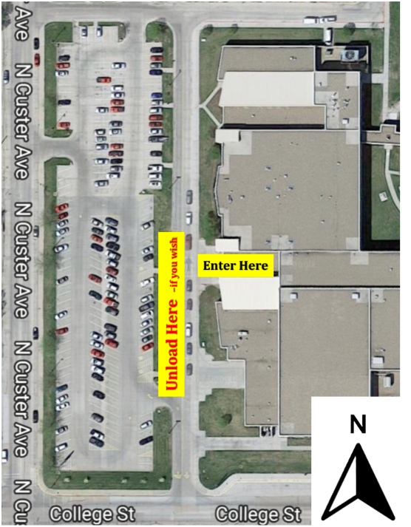
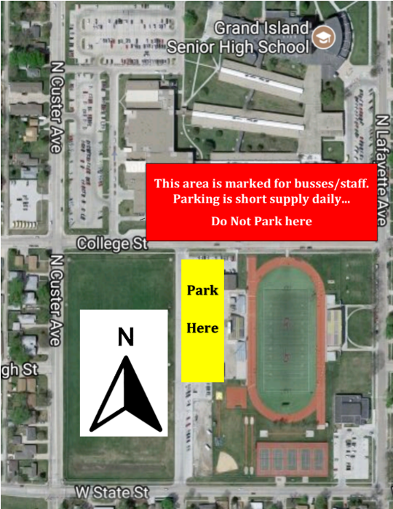

Grand Island Area College Fair
Time: 1:00pm to 2:30pm
Location: Northwest High School
Address: 2710 N. North Road Grand Island, NE 68803
Host Site Contact: Lori Merritt, School Phone 308-385-6394, lmerritt@ginorthwest.org
Cell 308-391-1499
Details: Representatives may park in the lot east of the school (along North rd) and the gravel lot to the east of the track. You can enter through the main doors on the east side of the building (map is attached). Reps may begin setting up any time after 12:30 pm. We will have student reps available to help carry items and direct you to the gym.

High Schools Invited: Aurora, Central City, Centura, Doniphan, Elba, Fullerton, Giltner, GI Central Catholic, Giltner, Heartland Lutheran, Nebraska Christian, Palmer, St. Paul.

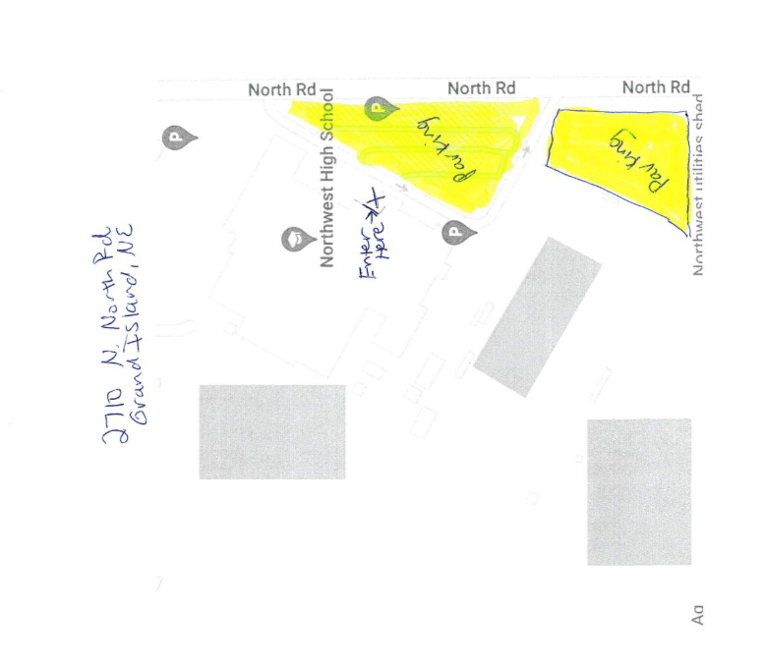
Weekly Social!
Day: Tuesday, September 29th
Time: 6:30pm
Location: Cunningham’s Journal – On the Bricks
Address: 15 W 23rd St, Kearney NE

Wednesday, September 30th
Kearney Area College Fair
Time: 9:00am to 10:30pm
Location: Kearney High School, Performance and Activity Wing (PAW)
Address: Kearney High School; The PAW; 2702 W 11st ST, Kearney NE 68845
Host Site Contact: Trent Steele, Email: tresteele@kearneycats.com. School phone: 308-698-8082.
Details: Reps may begin setting up any time after 8:30 am. (The entrance to the PAW is on the SOUTHWEST side of the building. Use the second entrance off of 30th AVE and park in the first parking lot on your right. You will enter the PAW through door #14. Overflow parking is available in the parking lot directly south of the PAW, doors #11 and #13 will also be open). *No food or drink of any kind is allowed in the PAW. We apologize for any inconvenience.

High Schools Invited: Amherst, Axtell, Elm Creek, Gibbon, Kearney Senior High School, Minden, Pleasanton, Ravenna, Shelton
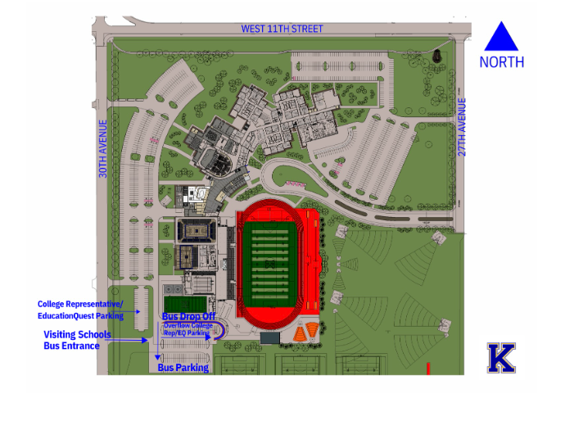

Broken Bow Area College Fair
Time: 1:30pm to 3:00pm
Location: Broken Bow High School
Address: 323 N. 7th Ave, Broken Bow, NE 68822
Host Site Contact: Ed Schaaf, School Phone 308-872-2475, ed.schaaf@bbps.org, Cell 308-870-4958
Details: The college fair will be held at the HS gym.Parking is a challenge at BBHS. Representatives may park in any available spot. There are two gravel lots southeast of the HS. You can enter through the main doors on the south side of the building. Reps may begin setting up any time after 12:45 pm. Student reps will be available to help carry items and direct you to the gym. Broken Bow will have grades 9-12 in attendance. Grades 11-12 will attend 1:30 - 2:10. Grades 9-10 will attend 2:14 -3:00

High Schools Invited: Anselmo-Merna High School, Ansley Public School, Arcadia Public Schools, Arnold High School, Callaway High School, Litchfield High School, Loup County Public School, Sandhills High School, Sargent Public Schools

Thursday, October 1st
Ord Area College Fair
Time: 9:00am to 10:00am
Location: Ord High School
Address: 1800 K Street, Ord NE 68862
Host Site Contact: Lana Kruml School Phone 308-728-3241, lkruml@ordps.org cell 308-201-1449
Details: College Fair will be in the new gym/new commons. Representatives may park in the lot east of the school (N. 17th Street). You can enter through the east doors on the east side of the building. Reps may begin setting up any time after 8:15 a.m. Most of the tables will be round tables. Coffee and water will be available for representatives.

High Schools Invited: Arcadia, Burwell, Central Valley, Loup City, Loup County, Riverside, Spalding Academy and Wheeler Central

Ainsworth Area College Fair
Time: 1:00pm to 2:00pm
Location: Ainsworth High School
Address: 520 E 2nd St, Ainsworth, NE 69210
Host Site Contact: Lisa Schlueter, lschlueter@ainsworthshools.org or 402-387-2082, ext. 4129
Details: Parking is limited around the school, so please wear your walking shoes. You can park on the streets surrounding the school. (If you arrive between 12:20 and 12:40, you can take the students’ parking places while they are gone to lunch in the parking lot west of the school! 🙂). Enter the building by the Big A sign on the west side of the school. The gym is to the left, the restrooms are to the right.

High Schools Invited: Cody-Kilgore High School, Keya Paha County High School, Rock County High School, Valentine High School

